In python, Pickling is taking a list of data into a serialized format. This is useful for data that is in a wrong format.

Point 1)

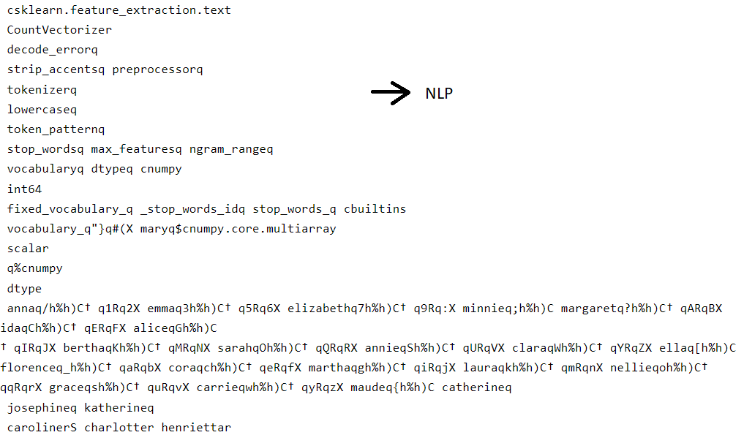Then the rest of the names are lists of objects that have been inputted.

Point 2)

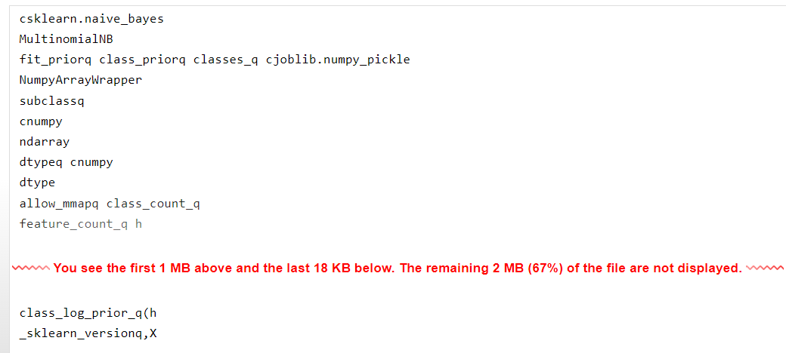

* Naïve bayes is a method to predict the probability of different class based on various attributes.
* The multinomial Naive Bayes classifier is suitable for classification with discrete features
* The rest of the codes are for machine learning, like feature count to find occurrence distribution, and to re-structure an array like ndarray, numpyarraywrapper.
* The model itself is not shown and can’t be shown.

IMPLEMENTATION

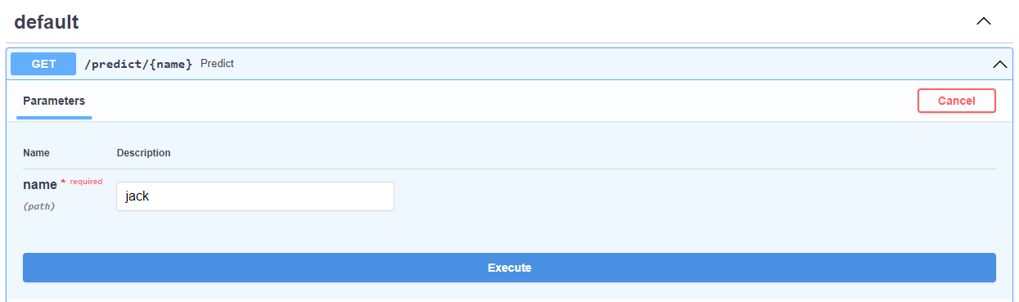press execute

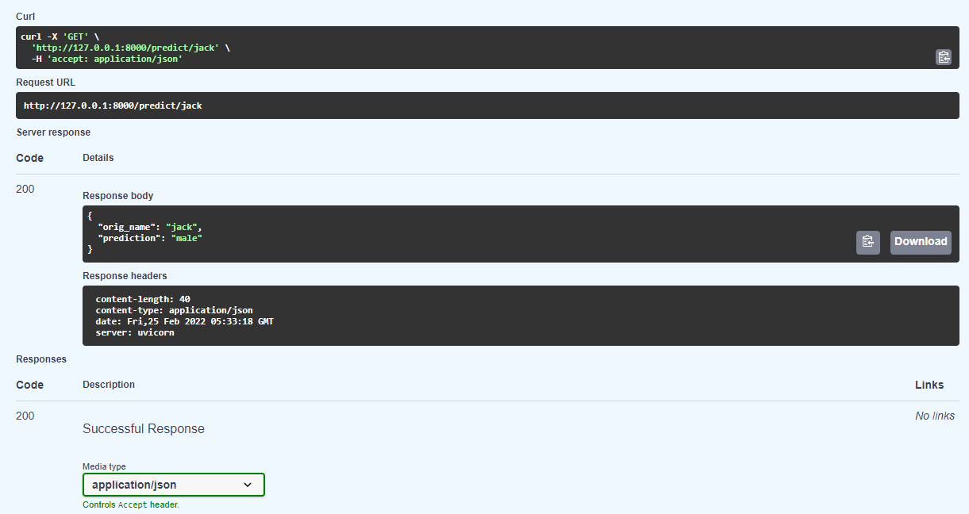When we input jack, the prediction is correct which is a male.